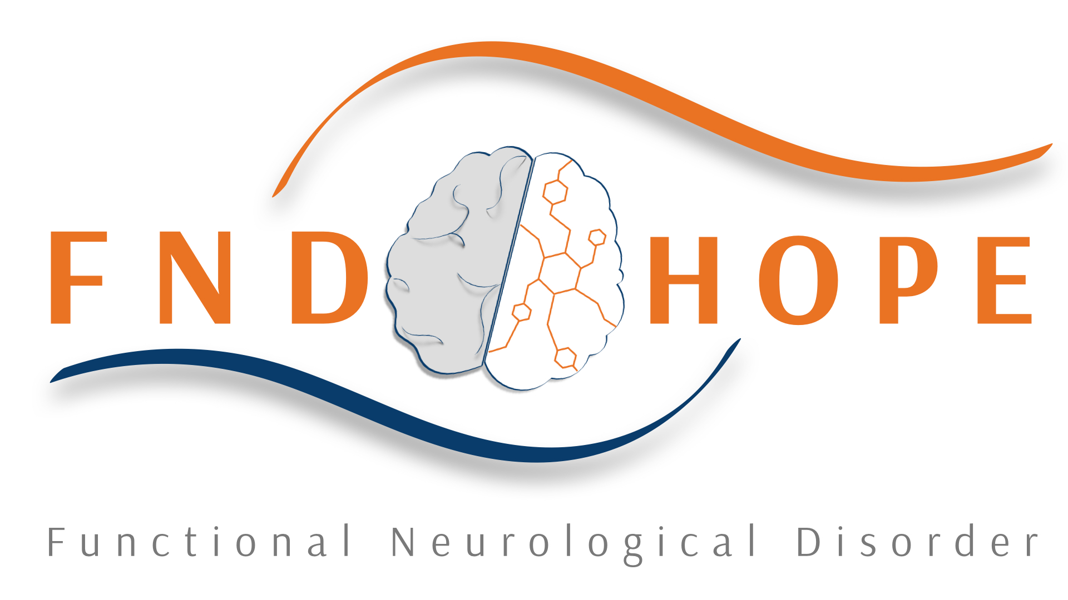
Marketing - FND Hope Inc.
2015
By

FND Hope:

Logo Use Guidelines

Introduction
The FND Hope logo is very important to us as it is a distinguishable brand and is easily recognized. Our logo is the way we communicate with volunteers and the people who we support as well as global research organizations, medical professionals and governments. It is therefore extremely important to us. As someone who is looking to use our logo it is important to understand that you will be representing FND Hope and it is important that you help us to protect our reputation by reproducing a consistent brand that is easily recognized and trusted. In order to do so, please read through this document carefully.
Though we do wish to protect our logo, we also do not want to prevent anyone from using it (proving that they follow the below guidelines and the correct code of practice as outlined in this document). We recognize that within the FND Hope community, we have many creative members whose skills help to raise vital funds and awareness for our charity. This document is tailored toward those who wish to use the logo in the reproduction of craft products but can equally be viewed as guidelines for organizations who are working in partnership with FND Hope.

Design guidelines
Please make use of the files supplied by us. Please ensure that you:
- Do not distort our logos in any way
- Do not turn these on their side – our logo must always appear horizontally
- Do not embed the logo in text or sentences
- Do not use as a large background or pattern
We have many variations of our logo which you can download and use for fundraising and awareness activities. Soon we will have a selection of template posters and sponsorships forms.

colour LOGOS AND TEXT
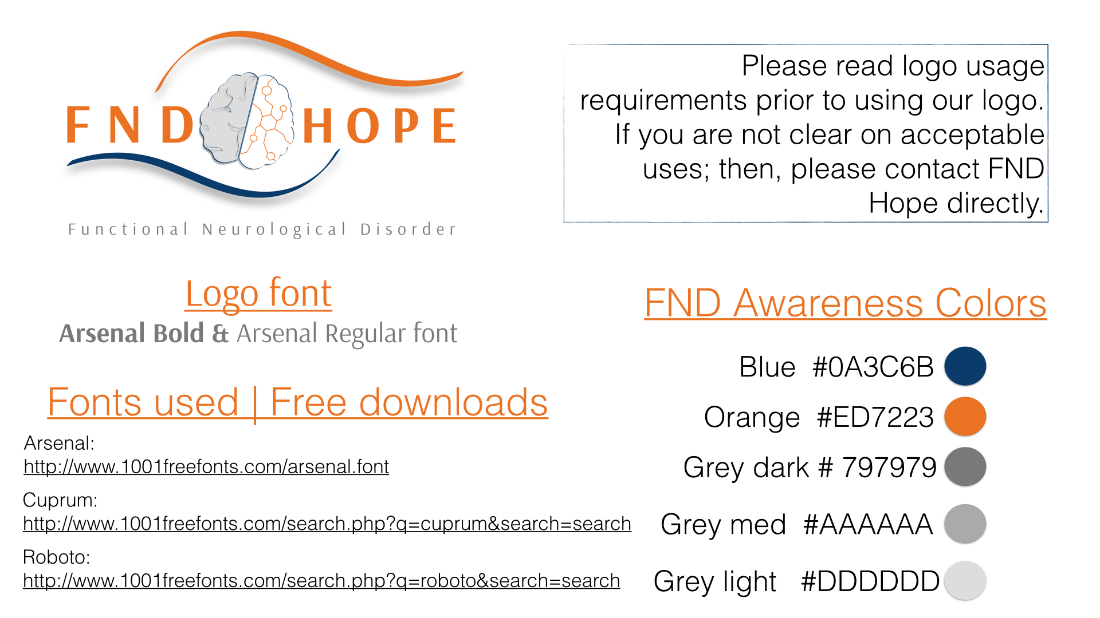

Black and white
2.45”X 5”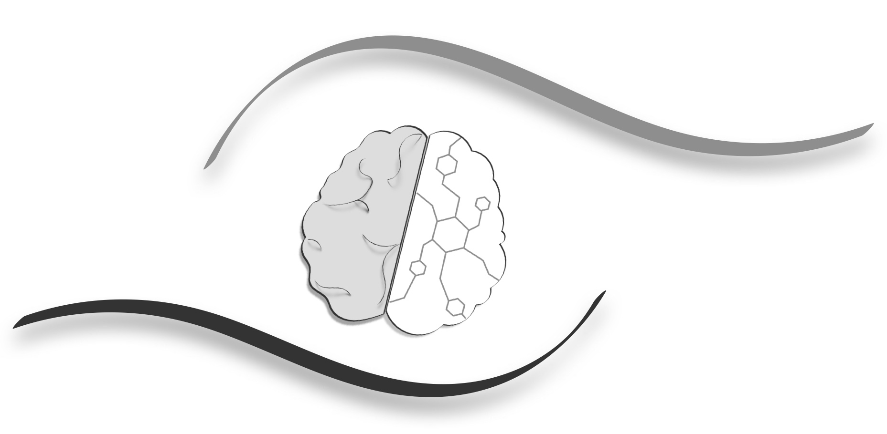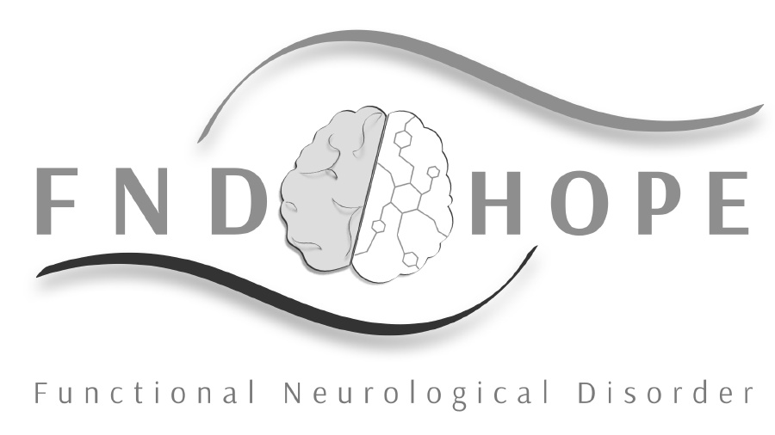

size
- The size of the logo must be:
- No smaller than 22mm across its length or 70 px across
- The logo should still be legible and not be distorted
- If being used on promotional material its size should be consistent with other logos
- Allow for ‘safe space’ and adequate size.
- Make legibility a priority

font
Arsenal Bold and Arsenal regular font
Can be found on 1001freefonts.com

other text
Cuprum http://www.1001freefonts.com/search.php?q=Cuprum&search=searc
Roboto http://www.1001freefonts.com/search.php?q=roboto&search=search
See above free links
Please follow our website for examples of use.

background
The logo should be reproduced on a clear background which is opaque and preferably white in color. It should not be placed directly onto a patterned background and should not be overlaid onto pictures or images.

postioning

If the FND Hope logo is to be used in conjunction with other logos, it must be placed an appropriate distance away to ensure that each logo is separate and clear. This ensures that each logo is able to clearly communicate its message.
The FND Hope logo should also be separate and clear from any headings and an effort should be made to ensure that text and images do not interfere with it. A variety of logos have been created to ensure that you will have the appropriate style and size for your work. However, should you find that you still struggle to position the logo in accordance to our guidelines, a member of our team may be able to assist you. You can contact us using the details under the additional points section of this document.

other points

Never cut anything off our logos. We have designed multiple logos to ensure that you will be able to position them onto a shirt, paper, mug, newsprint, web, posters, brochures etc..
PLEASE capitalize FND HOPE when using name as a stand- alone without logo. Preferred font is Arsenal.

